Supplementary Materials for
From Scientific Literature to Alloy Discovery: A
Corpus–Topic–Document Framework for Copper Alloy Informatics

Zixuan Zhao et al.

Corresponding author: Yanbin Jiang ( jiangyanbin@tsinghua.org.cn )
Tong Xie (tong.xie@unsw.edu.au).

This Supplementary Materials document provides the methodological details, extended analyses, and validation data supporting the Corpus–Topic–Document framework presented in the main manuscript. The document is organized as follows:
- Notes S1–S7 describe the scientific findings reconstructed by CTD, the temporal publication landscape, BERTopic–UMAP semantic organization, CPSP-oriented knowledge reconstruction, feature-descriptor engineering, multi-objective property prediction, and ground-truth validation of literature filtering.
- Figures S1–S3 present the bibliometric evolution of copper-alloy research, topic-specific BERTopic–UMAP embeddings, and measured-versus-predicted performance for the evaluated machine-learning models.
- Tables S1–S6 report the bibliometric rank-flow definitions, physicochemical and knowledge-derived feature descriptors, optimized feature subsets, predictive performance, the composition of the resolved ground-truth database, and filtering metrics against the resolved labels.
References provide the sources cited throughout the Supplementary Notes, Figures, and Tables.

Contents

Note S1. Scientific Findings Revealed by the Corpus–Topic–Document Framework......................................3
Note S2. Topic Evolution and Publication Landscape Analysis of Copper-Alloy Research...........................11
Supplementary Figure S1. Time-varying annual rankings of copper-alloy publications................................14
Supplementary Table S1. Full names corresponding to the Top-10 rank flows..............................................14
Note S3. BERTopic–UMAP Visualization of Topic-Specific Semantic Clusters..............................................18
Supplementary Figure S2. BERTopic–UMAP visualization of copper-alloy literature....................................20
Note S4. Semantic Distribution and Copper-Alloy Knowledge Organization within CPSP............................21
Note S5. Feature Descriptor System for the Rapid Alloy-Design Module.......................................................31
Supplementary Table S2. Feature descriptors for synergistic optimization of Cu alloys...............................32
Supplementary Table S3. Optimized feature subsets for high-performance copper alloys..........................34
Note S6. Multi-Objective Prediction Performance of Machine-Learning Models...........................................35
Supplementary Table S4. Predictive performance of machine-learning models............................................36
Supplementary Figure S3. Comparison of measured and model-predicted properties.................................40
Note S7. Ground-Truth Validation of BERTopic–UMAP Semantic Filtering.....................................................41
Supplementary Table S5. Summary of the resolved ground-truth database..................................................44
Supplementary Table S6. Filtering performance against the resolved ground-truth labels..........................45
Supplementary Note S8. Distribution and Knowledge Coverage of the Final CPSP Database.....................46
References............................................................................................................................................................49

Supplementary Note S1. Scientific Findings Revealed by the Corpus–Topic–Document Framework

The proposed Corpus–Topic–Document (CTD) framework revealed a series of scientific findings spanning corpus-level literature patterns, topic-level semantic structures, document- level CPSP relationships, and downstream data-driven alloy design, as summarized below.

S1.1 Corpus-level findings-Knowledge discoveries from the global copper-alloy literature landscape

Finding 1. Copper-alloy research expanded markedly during 2020–2025 while remaining concentrated within a relatively stable publication ecosystem.
- Supporting evidence and interpretation:
Supplementary Figure S1 and Supplementary Table S1 track the annual rankings of the major publishers and journals contributing to copper-alloy research from 2020 to 2025. Elsevier and its affiliated imprints consistently maintained clear leadership throughout the study period, while Journal of Alloys and Compounds, Materials Science and Engineering A, and Journal of Materials Research and Technology remained the principal publication venues. At the same time, Materials & Design, Materials Characterization, and Journal of Materials Engineering and Performance showed more pronounced growth after 2023. These results indicate that copper-alloy research has expanded continuously within a publication ecosystem that remains concentrated around several dominant publishers and journals.

Finding 2. The global copper-alloy research ecosystem is becoming increasingly Asia-centered, with publication output, institutional leadership, and funding support showing a consistent geographical concentration.

- Supporting evidence and interpretation:
Supplementary Figure S1.C-F show the temporal evolution of publishing countries, research institutions, and funding agencies. China consistently dominates publication output, while India shows rapid growth and Japan and Russia remain comparatively stable. At the institutional level, the Chinese Academy of Sciences, Central South University, and the University of Science and Technology Beijing consistently rank among the leading contributors, supported by other major Chinese institutions such as Northeastern University and Harbin Institute of Technology. A similar pattern is observed in research funding, where the National Natural Science Foundation of China remains the dominant funding source, followed by the National Key R&D Program of China and several provincial foundations. The consistency among country-, institution-, and funding-level distributions indicates an increasingly Asia-centered copper-alloy research ecosystem.

Finding 3. Copper-alloy knowledge occupies a heterogeneous, long-tailed, and cross-domain semantic landscape rather than a single isolated literature region.

- Supporting evidence and interpretation:
Figure 2A–B shows that BERTopic–UMAP identified 457 non-noise semantic clusters from 122,982 alloy-related publications, with the largest individual cluster accounting for only 2.57% of the corpus. The remaining clusters exhibit a pronounced long-tail distribution, while dense local topic regions remain globally interconnected in the semantic space. Copper-alloy-related publications are not confined to a single semantic cluster but are distributed across multiple neighboring research domains, including mechanics, corrosion, high-entropy alloys, irradiation, and shape-memory alloys. These results demonstrate that copper-alloy knowledge is semantically heteroge-neous and extensively connected with adjacent materials-research domains.

Finding 4: Copper-alloy research is undergoing a gradual shift from composition- and performance-centered development toward microstructure-informed, processing-mediated, and engineering-oriented design.

- Supporting evidence and interpretation:
Supplementary FigS1.E shows that microstructure, mechanical properties, evolution, strength, precipitation, temperature, deformation, corrosion, and phase remain among the dominant research keywords. The temporal analysis further shows that microstructure, mechanical properties, and evolution remain persistent high-frequency themes, while corrosion and processing-induced precipitation behavior have gained increasing attention in recent years. The Supplementary Materials explicitly interpret this transition as a gradual shift from composition-centered alloy development toward more integrated strategies emphasizing microstructure-informed and engineering application-oriented design, together with increasing integration of processing–structure–property relation-ships with reliability, durability, and functional requirements.

S1.2 Topic-level findings Knowledge organization revealed by semantic topic modeling

Finding 5. The heterogeneous copper-alloy literature can be organized into seven scientifically interpretable thematic domains with a clear hierarchical and long-tail structure.

- Supporting evidence and interpretation:
Figure 2C–D, Figure 3A–D, and Table 1 collectively characterize the LDA-derived thematic organization of the copper-alloy corpus. The coherence score reaches its maximum at seven topics, while the reconstructed topics correspond to recognizable research directions including structure–property relationships, corrosion, interfacial reactions, electrodeposition, solidification/diffusion, amorphous systems, and functional materials. At the same time, Figure 3B shows an uneven topic-weight distribution, with several dominant themes accompanied by smaller but meaningful topics, forming a clear long-tail structure. These results indicate that copper-alloy research is neither randomly distributed nor uniformly partitioned, but instead organized into a limited number of scientifically interpretable domains with distinct levels of prominence.

Finding 6. Structure–property relationships remain central to copper-alloy research, while the field is increasingly shifting toward service-oriented performance and application-relevant behavior.

- Supporting evidence and interpretation:
Figure 2D and Figure 3D show that structure-related studies consistently occupy a major proportion of the literature, confirming the persistent importance of linking microstructure with properties in copper-alloy research. Meanwhile, the increasing prominence and temporal variation of topics such as corrosion, surface reactions, wear, interfacial phenomena, and other environment-dependent behaviors indicate a growing emphasis on alloy performance under practical service conditions. Together, these trends suggest that copper-alloy research is evolving from primarily structure–property optimization toward a more application- oriented paradigm that integrates microstructural regulation with service performance, reliability, and environmental response.

Finding 7. The major thematic domains are semantically distinguishable but not completely isolated, revealing a structured and partially interconnected knowledge landscape.

- Supporting evidence and interpretation:
The inter-topic correlation matrix in Figure 3C shows moderate correlations among the reconstructed topics, indicating clear thematic separation. Figure 2C shows that these topics remain partially connected within the semantic space rather than forming completely isolated clusters. This combination of distinguishable and limited semantic overlap suggests that copper-alloy research organized into identifiable thematic modules while retaining shared scientific concepts across neighboring research directions.

S1.3 Document-level Scientific findings from the reconstructed CPSP infrastructure

Finding 8. The reconstructed CPSP infrastructure transforms fragmented literature into reusable knowledge that can directly support alloy design.

- Supporting evidence and interpretation:
The document-level reconstruction integrates information extracted from text, tables, and scientific figures into unified CPSP records preserving composition, processing history, structural observations, strengthening mechanisms, properties, publication meta-data, and experimental context within machine-readable JSON documents. Reconstruct-ed CPSP infrastructure functions as a reusable knowledge resource from which task-specific datasets can be dynamically generated according to alloy system, processing route, target property, or metallurgical objective. This organization enables the same literature-derived knowledge to support knowledge mining, feature engineering, property prediction, and alloy design without repeatedly reconstructing alloy-specific databases.

Finding 9. CPSP-derived knowledge enables interpretable machine learning and experimentally validated alloy design.

- Supporting evidence and interpretation:
Task-specific datasets generated from the CPSP infrastructure supported CPSP-oriented feature engineering, multi-objective property prediction, Bayesian optimization, and subsequent experimental validation. The optimized feature subsets demonstrate that hardness, electrical conductivity, and Q3-Euclidean are governed by different CPSP descriptor combinations rather than a universal feature family. Guided by these knowledge-derived relationships, virtual screening of the composition–processing design space identified optimized Cu–Ni–Si–Cr alloy candidates, which were subsequently validated experimentally. Microstructural characterization further confirmed that the balanced mechanical and electrical performance originated from coordinated regulation of alloy composition, thermo-mechanical processing, retained deformation substructures, and nanoscale δ-Ni₂Si precipitation, thereby establishing a complete knowledge-driven pathway from literature organization to alloy discovery.

S1.4 Knowledge-utilization Scientific discoveries enabled by CPSP-guided machine learning
Finding 10. Balanced strength and electrical conductivity require coordinated regulation of precipitation, solute partitioning, and deformation through composition–processing coupling.

- Supporting evidence and interpretation:
Feature engineering reveals that hardness is primarily governed by Ni content, Ni/Si ratio, precipitation-related thermodynamic descriptors, deformation–aging coupling, aging intensity, and supersaturation, indicating that precipitation evolution and deformation strengthening dominate mechanical performance. In contrast, electrical conductivity is mainly controlled by Ni, Si, Ni/Si ratio, Cr-related descriptors, configura-tional/electronic features, and aging-related processing interactions, reflecting the importance of solute depletion, matrix purification, and electron scattering. The Q3-Euclidean index depends on a broader combination of compositional, thermodynamic, and processing descriptors, demonstrating that balanced performance cannot be achieved by optimizing a single variable. Therefore, high-performance Cu–Ni–Si alloys should be designed by jointly regulating precipitation evolution, solute partitioning, and deforma-tion through coordinated composition and thermo-mechanical processing.

Finding 11. Optimizing precipitation evolution while preserving a conductive Cu matrix is the fundamental design principle for high-performance Cu–Ni–Si alloys.

- Supporting evidence and interpretation:
The CTD framework identifies Ni content, Ni/Si ratio, Cr micro-alloying, deformation, and aging as recurrent key variables across literature. These variables collectively regulate δ-Ni₂Si precipitation, retained deformation substructures, and matrix purification. Experimental validation confirms that the optimized alloy achieves balanced strength and conductivity through uniform nano-sized δ-Ni₂Si precipitates, moderate retained dislocations, and a purified Cu matrix. Therefore, core metallurgical objective is controlled precipitation evolution with minimum electron scattering, rather than maximizing precipitation alone. It also verify that simultaneous optimization of precipitation behavior, matrix chemistry, and thermo-mechanical processing is essential for achieving balanced mechanical and electrical properties.

Note S2: Topic Evolution and Publication Landscape Analysis of Copper-Alloy Research (2020–2025)

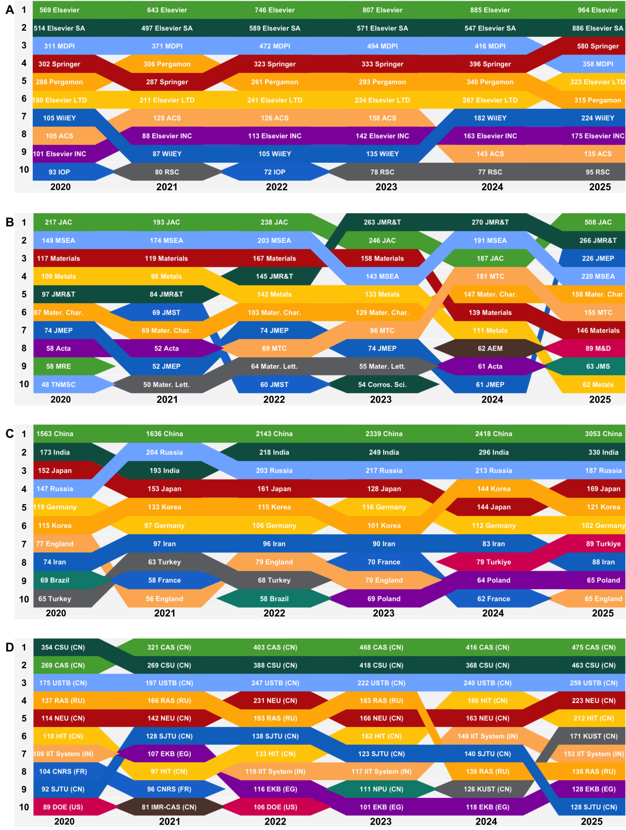
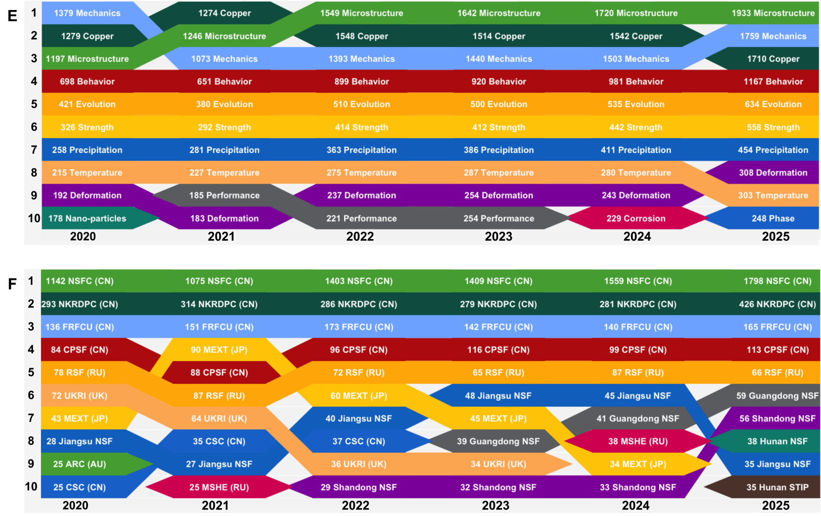
Supplementary Figure 1. Time-varying annual rankings (2020–2025) of major publication- related factors and research attributes in copper-alloy–related literature. Figures A–F track the dynamic changes in the Top.10 contributors across the six dimensions of Main publishers (Figure A), Publication journals (Figure B), Publishing countries (Figure C), Research institutions (Figure D), Author keywords (Figure E), Funding agencies (Figure F). Colored streams in the the figures depict changes in ranking positions over time, highlighting shifts in influence and research focus within each category from 2020 to 2025.

Supplementary Table 1. Full names corresponding to Top-10 rank flows (2020– 2025) across publishers, journals, countries, institutions, keywords, and funding agencies in copper-alloy-related literature.
Tracking Factor | Major Contributors from 2020 to 2025
Publishers  (Figure 1.A) | ELSEVIER (Elsevier, Elsevier SA, Elsevier LTD, Elsevier IND), PERGAMON-ELSEVIER SCIENCE LTD (Pergamon), WILEY-V C H VERLAG GMBH (Wiley), SPRINGER (Springer), ROYAL SOC CHEMISTRY (RSC), AMER CHEMICAL SOC (ACS), IOP Publishing Ltd (IOP), Multidisciplinary Digital Publishing Institute (MDPI)
Journals  (Figure 1.B) | Journal of Alloys and Compounds (JAC), Materials Science and Engineering A–Structural Materials: Properties, Microstructure and Processing (MSEA), Materials, Metals, Journal of Materials Research and Technology (JMR&T); Materials Characterization (Mater. Char.), Journal of Materials Science & Technology (JMST), Journal of Materials Engineering and Performance (JMEP), Acta Materialia (Acta), Materials Research Express (MRE), Transactions of Nonferrous Metals Society of China (TNMSC), Materials Today Communications (MTC), Materials Letters (Mater. Lett.), Corrosion Science (Corros. Sci.), Advanced Engineering Materials (AEM), Materials & Design (M&D), Journal of Materials Science (JMS)
Publishing countries  (Figure 1.C) | People Republic of China (China), India, Japan, Russia, Germany, Republic of Korea (South Korea), United Kingdom (England), Iran, Brazil, Türkiye, France, Poland
Research institutions  (Figure 1.D) | Chinese Academy of Sciences (CAS), Central South University (CSU), University of Science and Technology Beijing (USTB), China Northeastern University (NEU), Harbin Institute of Technology (HIT), Kunming University of Science and Technology (KUST), Indian Institute of Technology System (IIT System), Russian Academy of Sciences (RAS); Egyptian Knowledge Bank (EKB), Shanghai Jiao Tong University (SJTU), Centre National de la Recherche Scientifique (CNRS), Institute of Metal Research-Chinese Academy of Sciences (IMR-CAS), United States Department of Energy (DOE), Northwestern Polytechnical University (NPU)
Author keywords  (Figure 1.E) | Copper, Microstructure, Mechanics (Mechanical Properties), Behavior, Evolution, Strength, Precipitation, Temperature, Deformation, Nano-particles, Performance, Corrosion, Phase
Funding agencies  (Figure 1.F) | National Natural Science Foundation of China (NSFC), National Key R&D Program of China (NKRDPC), Fundamental Research Funds for the Central Universities (FRFCU), China Postdoctoral Science Foundation (CPSF), Russian Science Foundation (RSF), Natural Science Foundation of Jiangsu Province (Jiangsu NSF), Guangdong Basic and Applied Basic Research Foundation (Guangdong NSF), Natural Science Foundation of Shandong Province (Shandong NSF), Natural Science Foundation of Hunan Province (Hunan NSF), Science and Technology Innovation Program of Hunan Province (Hunan STIP), Ministry of Education, Culture, Sports, Science and Technology, Japan (MEXT), Ministry of Science and Higher Education of the Russian Federation (MSHE), UK Research & Innovation (UKRI), Australian Research Council (ARC), China Scholarship Council (CSC), Russian Foundation for Basic Research (RFBR).

Supplementary figures A-F illustrate time-varying annual Top-10 rankings (2020–2025) of major publication-related factors and research attributes in copper-alloy–related literature, encompassing six interrelated dimensions: publishers, publication journals, publishing countries, research institutions, author keywords, and funding agencies. The patterns reveal sustained growth in research output alongside thematic and geographical shifts within the research landscape of copper alloy, indicating the transformation of the research focus despite contributions remain concentrated among a relatively small group of dominant scholars.
To elucidate structural evolution and competitive landscape of copper-alloy research, a series of time-resolved rankings were analyzed using a bump-chart toolkit implemented in R. As illustrated in figures 1A and 1B, the publication ecosystem remains highly concentrated within a limited number of dominant entities. Elsevier and its affiliated publishing imprints consistently maintain clear leadership throughout 2020-2025, whereas Springer, MDPI, and Wiley show limited growth in publication share. A comparable pattern emerges at the journal level: Journal of Alloys and Compounds (JAC), Materials Science and Engineering A (MSEA), and Journal of Materials Research and Technology (JMR&T) consistently remain the most popular publication for copper-alloy research. In contrast, journals such as Materials & Design (M&D), Materials Characterization (Mater. Char.), and Journal of Materials Engineering and Performance (JMEP) exhibit more pronounced growth after 2023. Importantly, the keyword dynamics in Figure.1E highlight similar thematic trends: while microstructure, mechanical properties, and evolution continue to dominate, recent years show growing emphasis on corrosion and processing-induced precipitation behavior. These dynamics suggest a gradual shift from composition-centered alloy development toward more integrated research strategies emphasizing microstructure-informed and engineering application-oriented design requirements. From a geographical perspective, China overwhelmingly leads in both publication output and funding acknowledgments, with sustained growth throughout the study period (figures 1C and 1D). India shows rapid growth, whereas Russia and Japan remain relatively stable. In contrast, United Kingdom, Iran, and France exhibit fluctuations or moderate declines. These patterns indicate a gradual shift of global publication landscape in copper-alloy research increasingly transitioning from Europe toward an Asia-centered structure. At the institutional level, the Chinese Academy of Sciences (CAS), Central South University (CSU), and the University of Science and Technology Beijing (USTB) consistently rank among the top three contributors in copper-alloy research. They are further supported by other major Chinese universities, including Northeastern University (NEU) and Harbin Institute of Technology (HIT), while international institutions show comparatively limited visibility. As shown in figures 1E, the funding landscape exhibits a similar distributional pattern. The National Natural Science Foundation of China (NSFC) remains the dominant funding source, followed by the National Key R&D Program of China and several provincial foundations throughout 2020–2025. International agencies, including the Russian Science Foundation (RSF) and Japan’s MEXT, contribute at comparatively lower but stable levels.
Overall, copper-alloy research during 2020-2025 exhibits a pronounced expansion in both scale and intensity with markedly increasing publication output, particularly in Asia. Moreover, it focus has progressively shifted from performance-targeted design toward precipitation behavior-centered and engineering-oriented development. This transition reflects maturation of the discipline, wherein processing-structure-property relationships are integrated with reliability, durability, and functional requirements.

Note S3: BERTopic-UMAP-Based Visualization of Topic-Specific Semantic Clusters in Copper-Alloy Literature

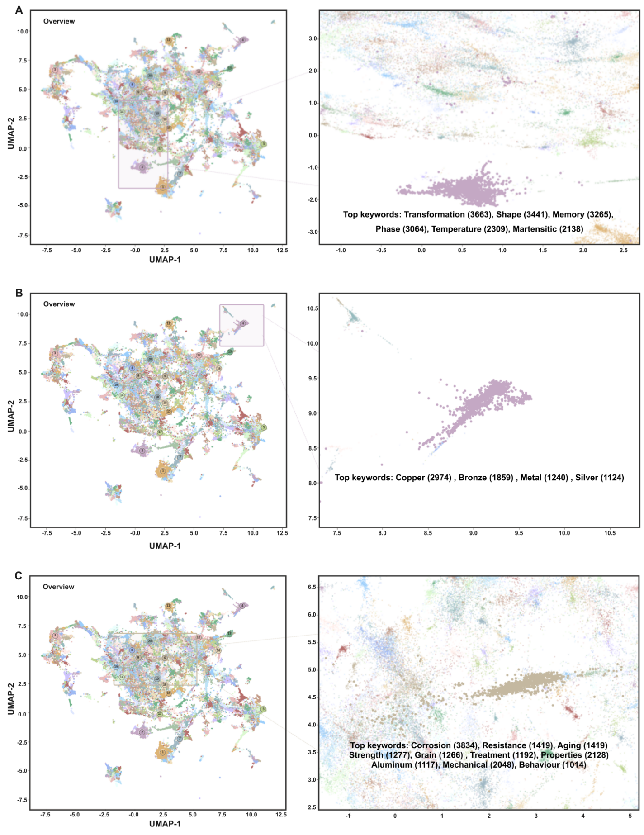

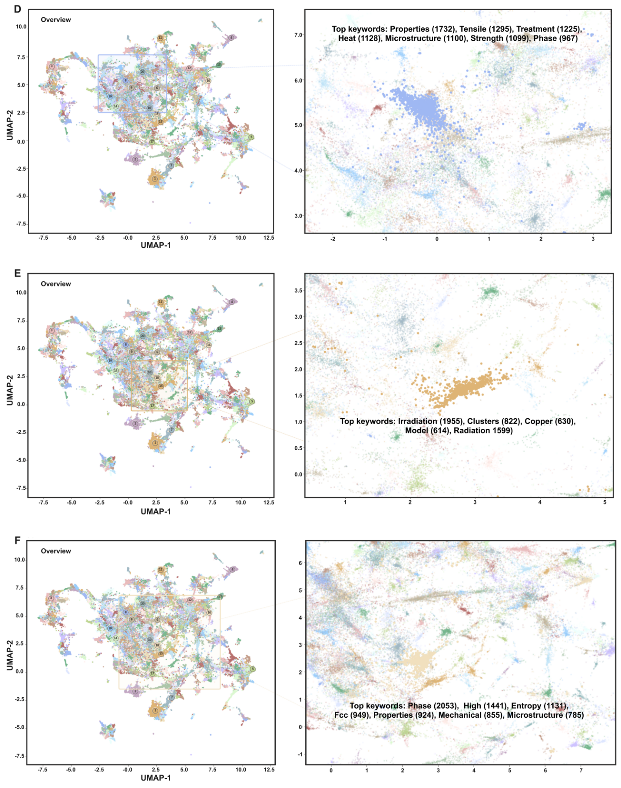
Supplementary Figure 2. BERTopic-UMAP based visualization of semantic embeddings for selected topics in copper-alloy-related literature. (A) Topic 2; (B) Topic 4; (C) Topic 6; (D) Topic 8; (E) Topic 15; (F) Topic 18. In each panel, the left subfigure shows the global embedding space with the selected topic highlighted, and the right subfigure shows the zoomed-in view of the corresponding topic cluster with its top keywords.

Note S3: Semantic Distribution and Copper-Alloy Knowledge Organization within the CPSP Infrastructure

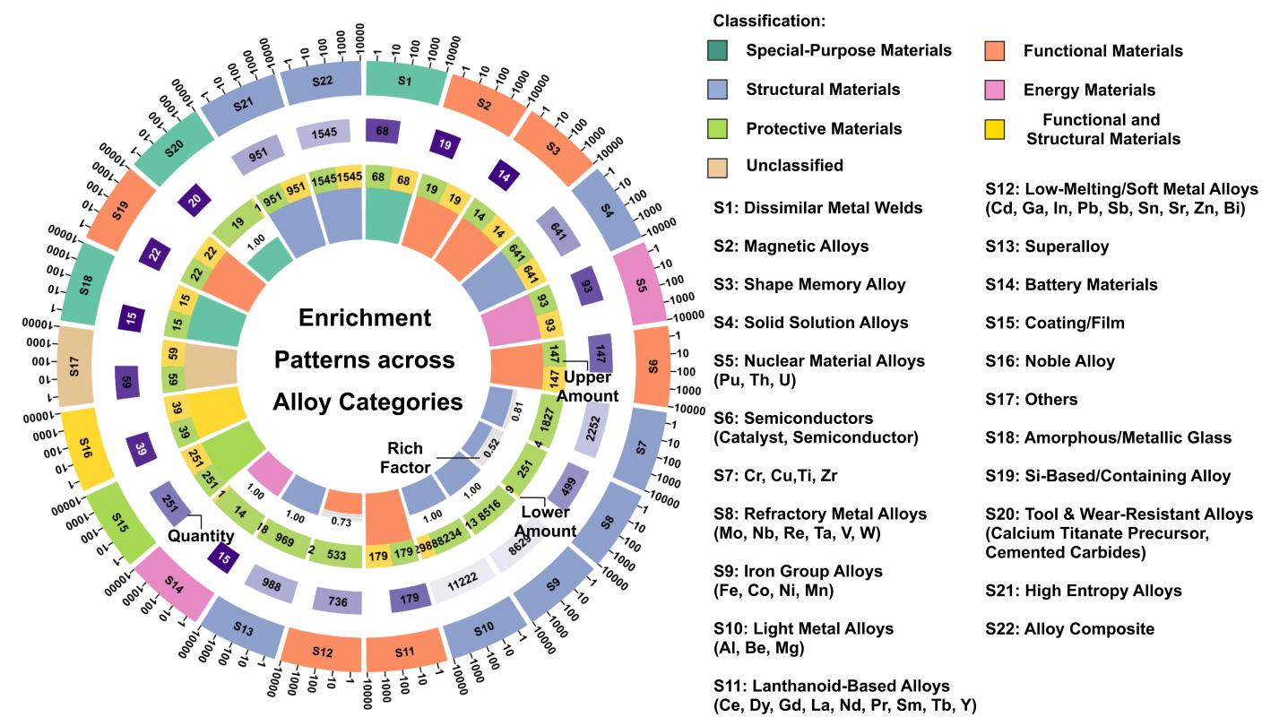
Fig.S3 Semantic organization of alloy categories within CPSP framework. A radial enrichment plot summarizes the distribution and significance of 22 alloy groups across six classification domains: special-purpose, functional, structural, energy, protective, and multifunctional materials. Each sector represents one alloy group, annotated with its quantity (purple bar), upper and lower bound counts (green and yellow bars), and rich factor (gray band, ranged from 0-1). The color-coded outer ring reflects the statistical significance of enrichment within each classification.

Table S2 Statistical distribution of alloy categories within the CPSP semantic infrastructure

Material | Classification | Proportion | Frequency | Upper Freq | Lower Freq | Elements
Dissimilar Metal Welds | Special-Purpose Materials | 0.0021 | 68 | 68 | 68
Magnetic Alloys | Functional Materials | 0.0006 | 19 | 19 | 19
Shape Memory Alloy | Functional Materials | 0.0004 | 14 | 14 | 14
Solid Solution Alloys | Structural Materials | 0.0197 | 641 | 641 | 641
Nuclear Material Alloys | Energy Materials | 0.0029 | 93 | 93 | 93 | Pu, Th, U
Semiconductors | Functional Materials | 0.0045 | 147 | 147 | 147 | Catalyst, Semiconductor
Cu, Zr, Cr, Ti | Structural Materials | 0.0693 | 2252 | 1827 | 4
Refractory Metal Alloys | Structural Materials | 0.0154 | 499 | 251 | 9 | Mo, Nb, Re, Ta, V, W
Iron Group Alloys | Structural Materials | 0.2656 | 8629 | 8516 | 113 | Fe, Co, Ni, Mn
Light Metal Alloys | Structural Materials | 0.3454 | 11222 | 8234 | 2988 | Al, Be, Mg
Lanthanoid-Based Alloys | Functional Materials | 0.0055 | 179 | 179 | 179 | Ce, Dy, Gd, La, Nd, Pr, Sm, Tb, Y
Low-Melting/Soft Metal Alloys | Functional Materials | 0.0227 | 736 | 533 | 2 | Cd, Ga, In, Pb, Sb, Sn, Sr, Zn, Bi
Superalloy | Structural Materials | 0.0348 | 988 | 969 | 18
Battery Materials | Energy Materials | 0.0005 | 15 | 14 | 1
Coating/Film | Protective Materials | 0.0077 | 251 | 251 | 251
Noble Alloy | Functional & Structural Materials | 0.0012 | 39 | 39 | 39
Others | Unclassified | 0.0018 | 59 | 59 | 59
Amorphous/Metallic Glass | Special-Purpose Materials | 0.0005 | 15 | 15 | 15
Si-Based/Containing Alloy | Functional Materials | 0.0007 | 22 | 22 | 22
Tool & Wear-Resistant Alloys | Special-Purpose Materials | 0.0006 | 20 | 19 | 1 | Calcium Titanate Precursor, Cemented Carbides
High Entropy Alloys | Structural Materials | 0.0293 | 951 | 951 | 951
Alloy Composite | Structural Materials | 0.0476 | 1545 | 1545 | 1545

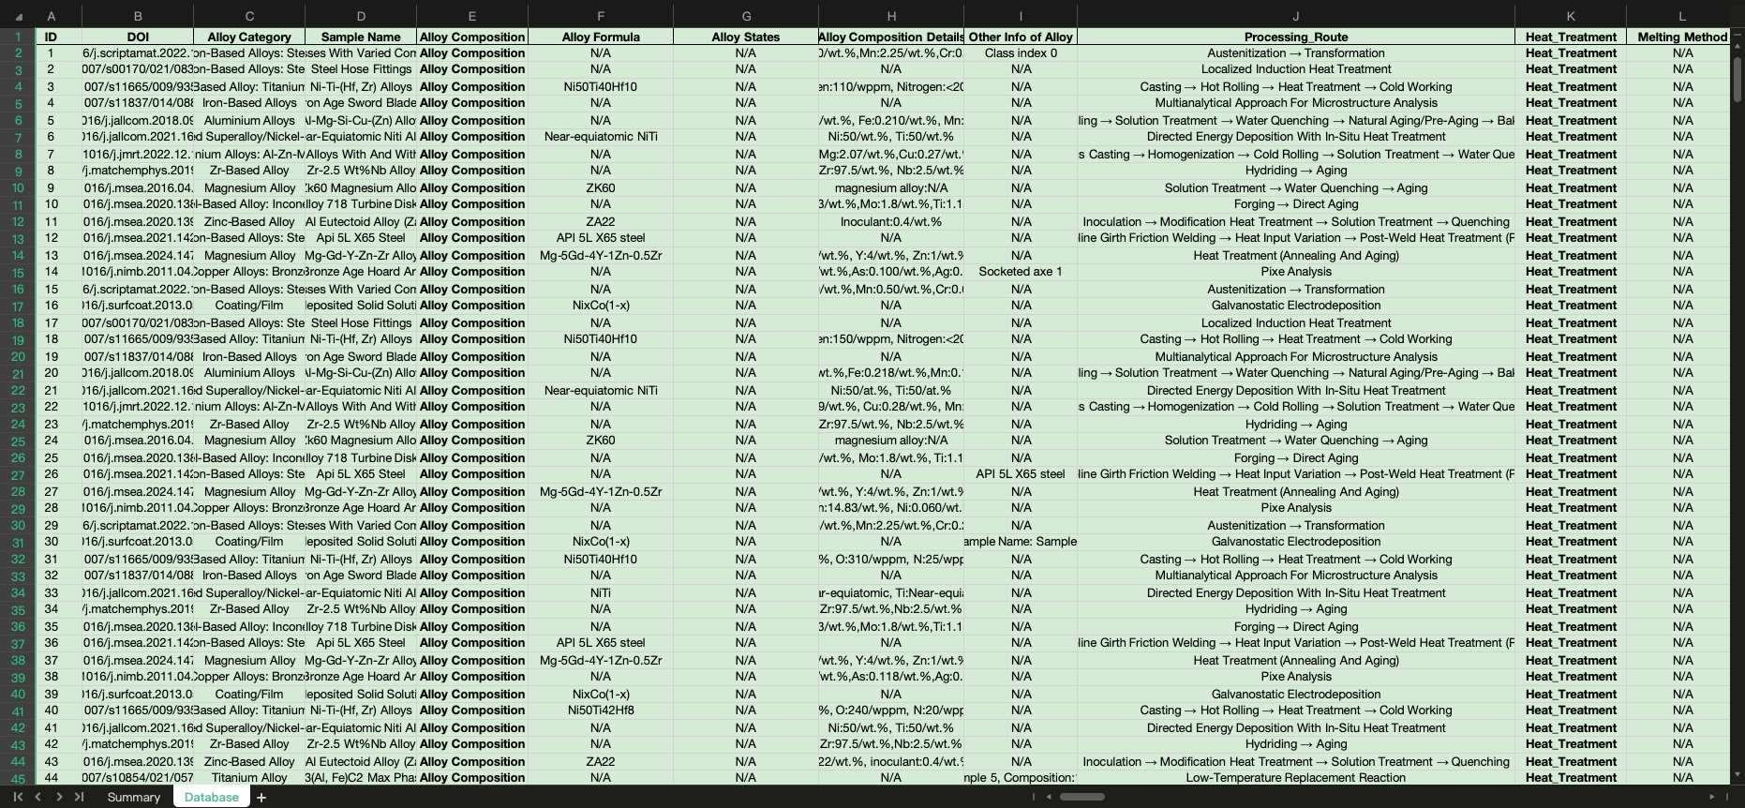
Fig.S4. Snapshot of the alloy CPSP database extracted using the CPSP framework in this study.Each row corresponds to a unique alloy data record, including metadata (e.g., DOI), as well as structured characteristics on composition, processing, structure, and performance “CPSP”. The database systematically integrates text-mined information from scientific literature to support downstream analysis of the CPSP relationships across diverse alloy systems.

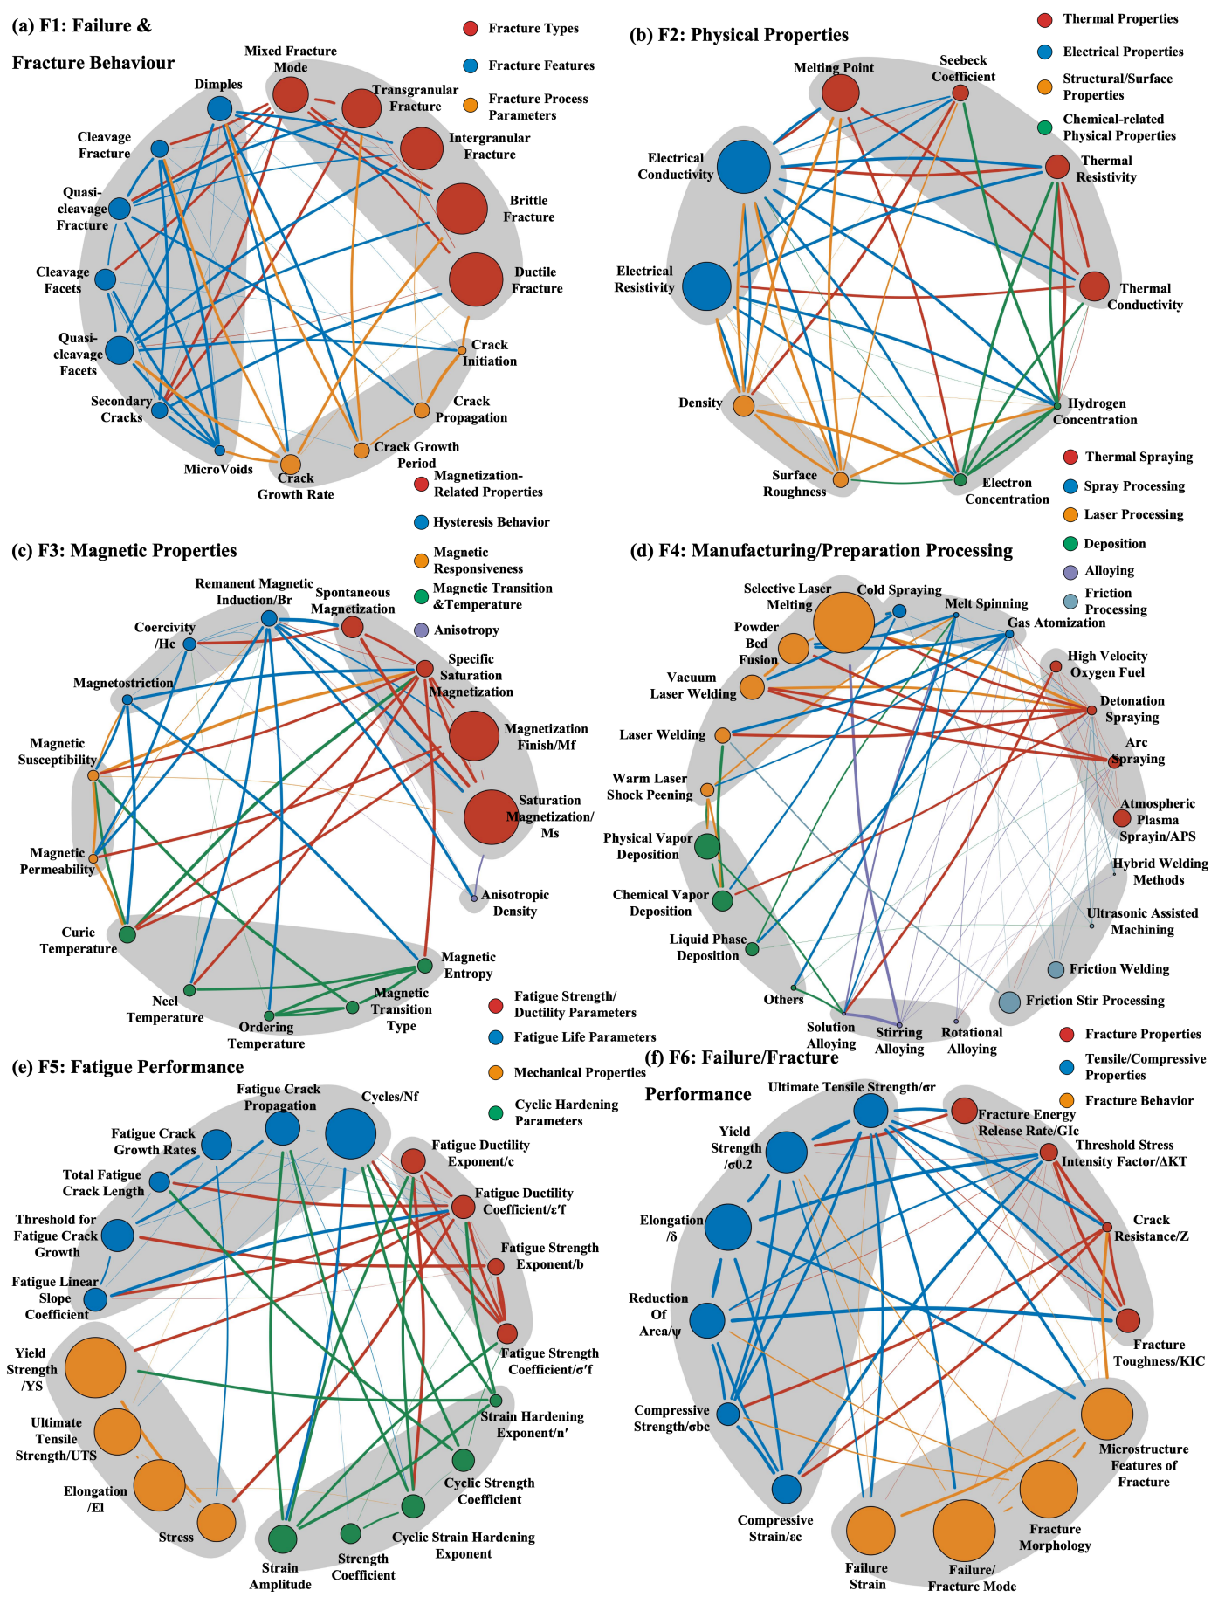
Fig.S5-a. Network analysis of feature co-occurrence within F1-F6 key thematic domains of the alloy database ranged from sub-graphs (a) to (f): (a) Failure & Fracture Behaviour; (b) Physical Properties; (c) Magnetic Properties; (d) Manufact -uring/Preparation Processing; (e) Fatigue Performance; (f) Failure/Fracture Performance.

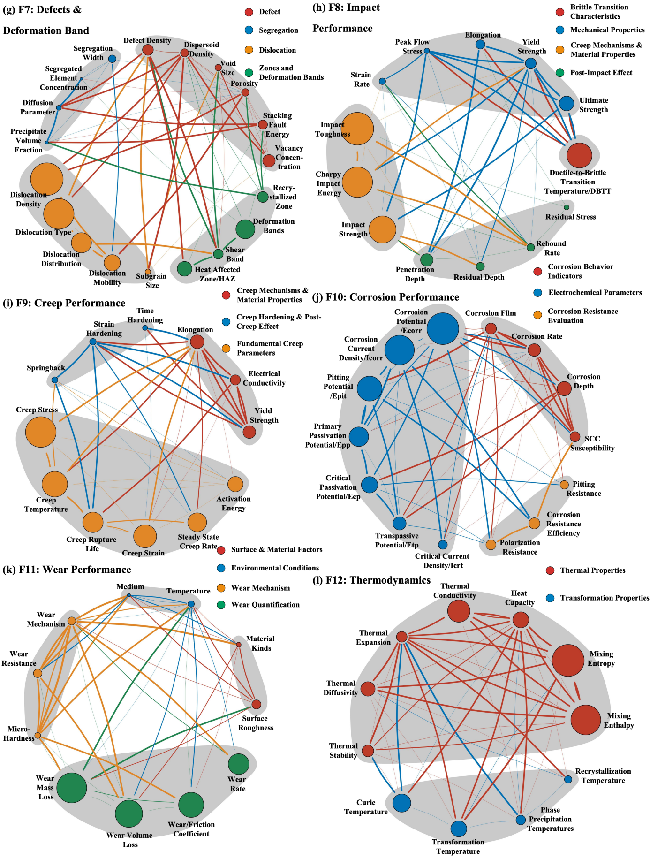
Fig.S5-b. Network analysis of feature co-occurrence within F7-F12 key thematic domains of the alloy database ranged from sub-graphs (g) to (l): (g) Defects & Deformation Bands; (h) Impact Performance; (i) Creep Performance; (j) Corrosion Performance; (k) Wear Performance; (l) Thermodynamic Properties.
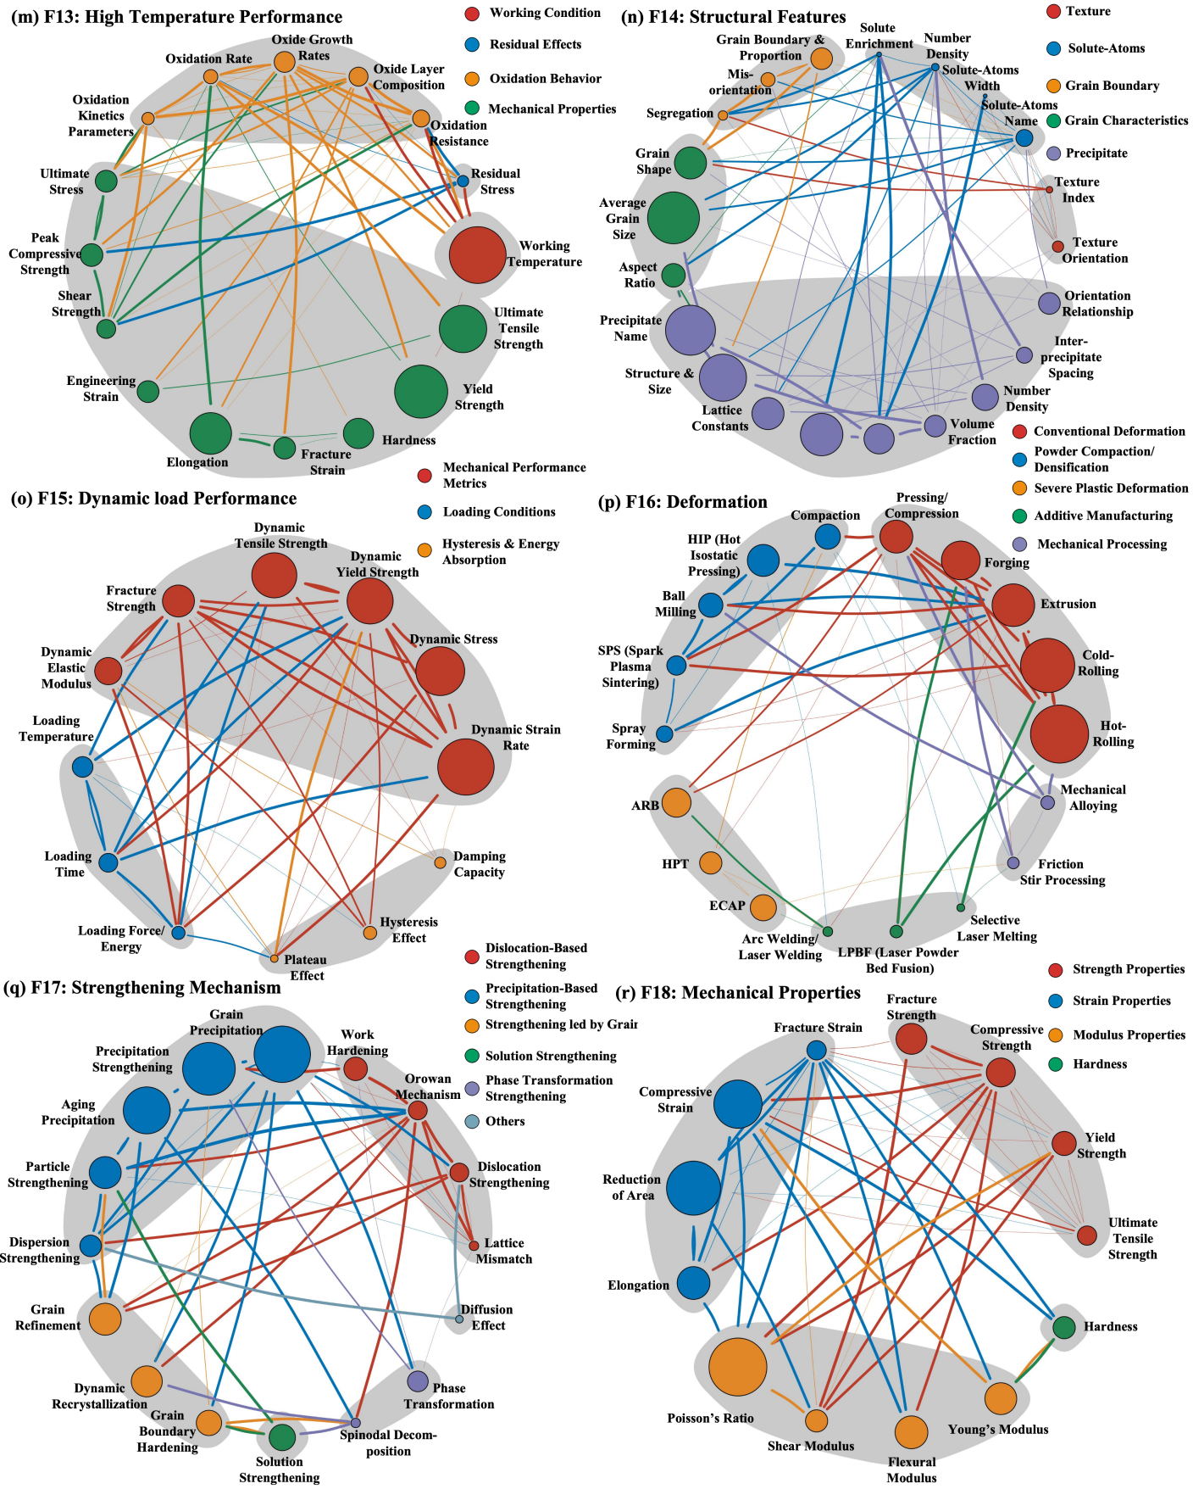

Fig.S5-c. Network analysis of feature co-occurrence within F13-F18 key thematic domains of the alloy database ranged from sub-graphs (m) to (r): (m) High Temperature Performance; (n) Structural Features; (o) Dynamic Load Performance; (p) Deformation; (q) Strengthening Mechanism; (r) Mechanical Properties.

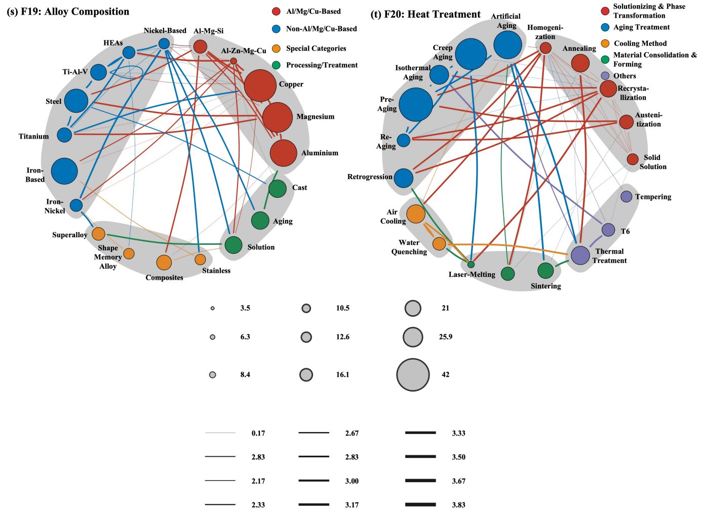
Fig.S5-d. Network analysis of feature co-occurrence within F19-F20 key thematic domains of the alloy database ranged from sub-graphs (s) to (t): (s) Alloy Composition; (t) Heat Treatment.

Note S5: Feature Descriptor System for Machine learning in the rapid alloy design module

Supplementary Table 2. Feature descriptors for synergistic optimization of Cu alloys
Feature | Formula | Meaning
Compositional Content
Family | Ni–Si base + modifiers: (0) ;  Cr base/Cr + modifiers: (1) ;  Cr–Ni–Si hybrid: (2) | Alloy_Family: Cu-Ni-Si, Cu-Cr, Cu-Ni-Si-Cr-Zr
Cu | Cu = Cu/wt.% | Copper content
Al | Al = Al/wt.% | Alloying element content
Cr | Cr = Cr/wt.% | Alloying element content
Mg | Mg = Mg/wt.% | Alloying element content
Ni | Ni = Ni/wt.% | Alloying element content
Si | Si = Si/wt.% | Alloying element content
Zr | Zr = Zr/wt.% | Alloying element content
Compositional Ratio and Alloy System Related Features
Total alloying content | TAlloying = 100 - W_{Cu} | Overall alloying level
Ni/Si | W_{Ni} / W_{Si} | Ni-Si balance related to δ-Ni₂Si precipitation tendency
Ni+Si | W_{Ni} + W_{Si} | Total Ni-Si solute level for precipitation strengthening
Ni*Si | W_{Ni} * W_{Si} | Coupled Ni-Si contribution to precipitate formation
Mg/(Ni+Si) | W_{Mg} / (W_{Ni} + W_{Si}) | Relative Mg addition against the Ni-Si precipitation system
Zr/(Ni+Si) | W_{Zr} / (W_{Ni} + W_{Si}) | Relative Zr addition forgrain-boundary/thermal stabilization against the Ni–Si system
Cr/Zr | W_{Cr} / W_{Zr} | Cr-Zr balance related to precipitation and thermal stability
Cr+Zr | W_{Cr} + W_{Zr} | Total Cr-Zr alloying level for precipitation strengthening
Cr*Zr | W_{Cr} * W_{Zr} | Synergistic Cr-Zr contribution to strengthening behavior
Mg/Cr | W_{Mg} / W_{Cr} | Relative Mg addition against the Cr-containing strengthening system
Cr/(Ni+Si) | W_{Cr} / (W_{Ni} + W_{Si}) | Relative dominance of the Cr system over the Ni-Si system
(Ni+Si)/Cr | (W_{Ni} + W_{Si}) / W_{Cr} | Relative dominance of the Ni, Si system over the Cr system
Hybrid_index | (W_{Ni} + W_{Si}) * W_{Cr} | Interaction strength between Ni, Si and Cr alloying systems
Composition-Derived Physical Descriptors
Herfindahl–Hirschman index (HHI) | $$HHI=\sum_{i=1}^{n}{c_{i}^{2}}$$ | Element concentration
Effective number of elements (N_eff) | $$N_{eff}=\frac{1}{HHI}=\frac{1}{\sum_{i=1}^{n}{c_{i}^{2}}}$$ | Effective element count
Atomic-Size-Mismatch | $$δ=\sqrt{\sum_{i=1}^{n}{c_{i}}{\left(1−\frac{r_{i}}{\bar{r}}\right)}^{2}}$$ | Lattice distortion strength
Average Electronegativity | $$χ_{Avg}=\sum_{i=1}^{n}{c_{i}}χ_{i}$$ | Average bonding characteristic
Electronegativity Variance | $$χ_{Var}=\sum_{i=1}^{n}{c_{i}}(χ_{i}−χ_{Avg})^{2}$$ | Chemical heterogeneity
Valence electron concentration variance | $$χ_{Var}=\sum_{i=1}^{n}{c_{i}}(χ_{i}−χ_{Avg})^{2}$$ | Electronic heterogeneity
Average valence electron concentration | $${VEC}_{Avg}=\sum_{i=1}^{n}{c_{i}} {VEC}_{i}$$ | Average electron concentration
Melting Temperature | $${Tm}_{Avg}=\sum_{i=1}^{n}{c_{i}} {Tm}_{i}$$ | Thermal stability
Mixing Entropy | $$S_{Mix}=−R\sum_{i=1}^{n}{(}c_{i}\ln{c_{i}})$$ | Configurational disorder
Processing Features
Processing_route | Solution ==> Quenching ==> Aging (0);  Solution ==> Quenching ==> Deformation ==> Aging (1);  Solution ==> Quenching ==> Deformation ==> Aging ==> Secondary TMP ==> Secondary Aging (2)
Solution Temperature | Solution_Temperature/℃ | Solution_Temperature
Solution Time | Solution_Time/h | Solution_Duration
Aging Temperature | Aging_ Temperature/℃ | Aging_Temperature
CR_Reduction | Cold_Rolling_Reduction/% | Cold_Rolling_Reduction
Aging Time | Aging_Time/h | Aging_Duration
Deformation-diffusion coupling | CR_x_ATem = CR_Reduction/% × Aging_ Temperature | Deformation-Diffusion coupling
Deformation-aging interaction | CR_x_Atime = CR_Reduction/% × Aging_Time | Deformation-Aging interaction
Aging intensity | ATem_x_Atime = Aging_Temperature × Aging_ Time | Aging intensity
Supersaturation window | STem-ATem = Solution_Temperature - Aging_ Temperature | Supersaturation window
Secondary TMP | Secondary_TMP = {0,1} | Secondary Thermal-Mechanical-Processing indicator
Target Properties
Hardness | HV (measured) | Mechanical strength
Electrical Conductivity | Conductivity/%IACS | Electrical performance
Q3-Euclidean | Q3 = Sqrt [((HV-HVmin)/ (HVmax-HVmin)-1)^2 + ((EC- ECmin)/(ECmax-ECmin)-1)^2] | Multi-objective performance metric

Supplementary Table 3. Optimized Feature Subsets for synergistic optimization of high-performance copper alloys
Target Performance | Selected Features
Hardness | Ni/wt.%，Ni/Si，(Ni+Si)/Cr, HHI, Alloying, N_eff, Tmavg, χvar, Smix, Family, One-Hot-Processing, CR_x_ATem, ATem_x_Atime, STem-ATem, VECvar
Electrical Conductivity | Ni/wt.%, Si/wt.%, Ni/Si, Ni*Si, Mg/Cr, Cr+Zr, Smix, N_eff, δ, Tmavg, HHI, Alloying, VECavg, One-Hot-Processing,  CR_x_ ATem, ATem_x_Atime, STem-ATem
Q3-Euclidean | Mg/(Ni+Si), One-Hot-Processing, CR_x_ATem,  ATem_x_Atime , STem-ATem, HHI, Tmavg, χvar,  Smix, δ, VECvar

Note S4 Multi-Objective Prediction Performance of Machine Learning Models for High performance Cu Alloys
Performance | Train_  R-squared | Train_  MAE | Train_  RMSE | Train_  MAPE | Train_  Accuracy | Test_  R-squared | Test_  MAE | Test_  RMSE | Test_  MAPE | Test_  Accuracy | Model
Conductivity | 0.74 | 4.45 | 6.17 | 11.82 | 88.18 | 0.74 | 5.11 | 6.78 | 13.99 | 86.01 | Cat-  Boost
Hardness | 0.86 | 21.19 | 28.65 | 11.16 | 88.84 | 0.85 | 22.37 | 29.55 | 12.21 | 87.79
Q3-Euclidean | 0.78 | 0.04 | 0.06 | 5.02 | 94.98 | 0.71 | 0.05 | 0.06 | 5.14 | 94.86
Conductivity | 0.66 | 5.16 | 7.02 | 12.87 | 87.13 | 0.64 | 6.07 | 7.98 | 15.90 | 84.10 | Extra Trees
Hardness | 0.80 | 27.13 | 34.87 | 14.91 | 85.09 | 0.79 | 26.53 | 34.83 | 14.26 | 85.74
Q3-Euclidean | 0.75 | 0.05 | 0.06 | 5.31 | 94.69 | 0.71 | 0.05 | 0.07 | 5.40 | 94.60
Conductivity | 0.81 | 3.58 | 5.23 | 9.31 | 90.69 | 0.76 | 4.50 | 6.51 | 12.12 | 87.88 | LGBM
Hardness | 0.86 | 21.77 | 29.11 | 11.64 | 88.36 | 0.85 | 22.49 | 29.45 | 12.22 | 87.78
Q3-Euclidean | 0.77 | 0.05 | 0.06 | 5.08 | 94.92 | 0.71 | 0.05 | 0.06 | 5.24 | 94.76
Conductivity | 0.71 | 4.68 | 6.51 | 12.26 | 87.74 | 0.71 | 5.28 | 7.15 | 14.07 | 85.93 | MLPNN
Hardness | 0.79 | 26.72 | 35.88 | 14.17 | 85.83 | 0.78 | 27.35 | 36.02 | 14.30 | 85.70
Q3-Euclidean | 0.72 | 0.05 | 0.07 | 5.66 | 94.34 | 0.70 | 0.05 | 0.07 | 5.59 | 94.41
Supplementary Table 4. Predictive performance of machine learning models on copper alloy properties

Conductivity | 0.62 | 4.17 | 7.42 | 9.37 | 90.63 | 0.56 | 5.83 | 8.75 | 14.32 | 85.68 | SVR
Hardness | 0.78 | 26.15 | 36.71 | 14.53 | 85.47 | 0.77 | 27.18 | 36.56 | 14.68 | 85.32
Q3-Euclidean | 0.76 | 0.05 | 0.06 | 5.28 | 94.72 | 0.70 | 0.05 | 0.07 | 5.50 | 94.50
Conductivity | 0.80 | 3.80 | 5.43 | 9.91 | 90.09 | 0.77 | 4.58 | 6.41 | 12.21 | 87.79 | XGB
Hardness | 0.81 | 24.63 | 33.58 | 13.36 | 86.64 | 0.81 | 24.50 | 33.11 | 12.94 | 87.06
Q3-Euclidean | 0.77 | 0.05 | 0.06 | 5.11 | 94.89 | 0.72 | 0.05 | 0.06 | 5.21 | 94.79

Note: CatBoost = Category Boosting; ExtraTrees = Extremely Randomized Trees; LGBM = Light Gradient Boosting Machine; MLPNN = Multi-Layer Perceptron Neural Network; SVR = Support Vector Regression; XGB = Extreme Gradient Boosting.

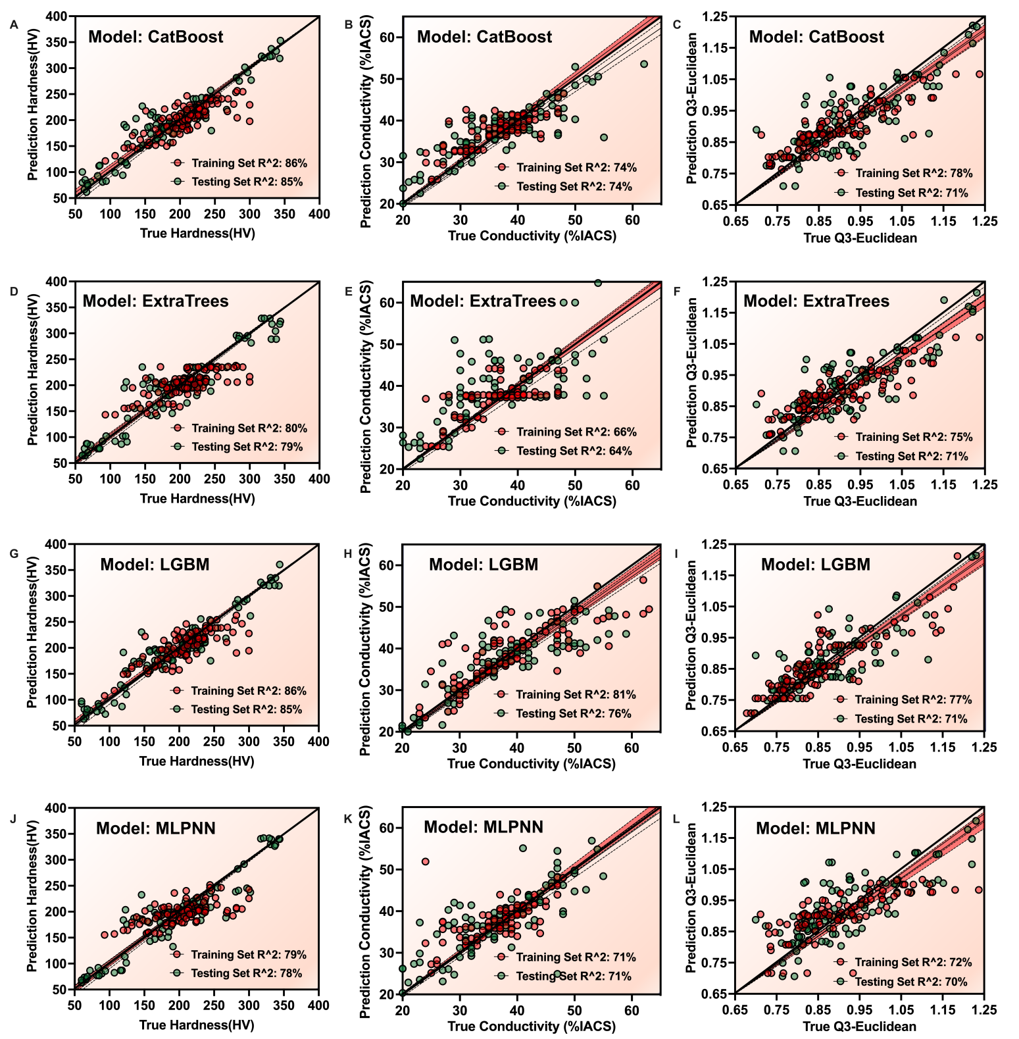

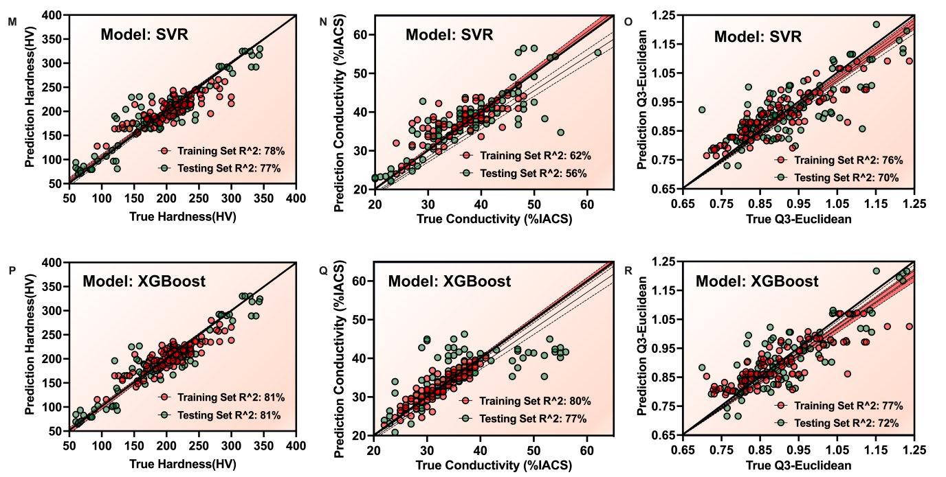
Supplementary Figure S3. Comparison between experimentally measured and model- predicted values of hardness (HV), electrical conductivity (%IACS), and Q3-Euclidean index for six machine learning models. (A-C) CatBoost; (D-F) Extra Trees (ET); (G-I) Light Gradient Boosting Machine (LGBM); (J-L) Multi-Layer Perceptron Neural Network (MLPNN); (M-O) Support Vector Regression (SVR); and (P-R) Extreme Gradient Boosting (XGBoost). The solid black line represents the ideal prediction line (y = x), while the shaded region indicates the corresponding confidence interval. Training and testing coefficients of determination (R²) are reported in each panel.

Note S7: Ground-truth Validation of BERTopic–UMAP Semantic Filtering

- Ground-truth database: A record-level ground-truth (GT) database was constructed to provide a common reference for evaluating the three literature-filtering strategies. The database comprised 500 publications sampled from the BERTopic-defined copper-alloy candidate cohort. Each record was assigned a persistent cohort identifier and linked to its original CTD document identifier to preserve provenance. The bibliographic layer retained the title, abstract, Author Keywords, Keywords Plus, DOI, Web of Science accession number, publication year, source title and document type. The semantic-evidence layer contained the BERTopic topic assignment, similarity to positive and negative semantic anchors, semantic margin and selection basis. A separate evaluation layer stored the outputs of keyword-only retrieval, full-metadata lexical retrieval and BERTopic–UMAP filtering. The reference layer recorded the resolved binary relevance label, material-scope category, annotation confidence, evidence-based rationale, review status and provenance of the annotation. This relational organization separated source metadata, model-derived evidence, reference labels and evaluation outcomes, thereby enabling every TP, TN, FP and FN to be reconstructed and traced to the original publication. The GT database therefore functioned not only as an evaluation set but also as an auditable data resource for examining the lexical omissions and semantic noise introduced by different corpus-construction strategies.

- Comparison design: Three literature-screening strategies were evaluated on the same 500- record dataset using an identical definition of copper-alloy relevance. The keyword-only baseline applied a predefined set of inclusion and exclusion expressions to the Author Keywords and Keywords Plus fields. The inclusion dictionary covered generic terms, such as “copper alloy” and “Cu alloy,” together with commonly used Cu-based alloy designations. Exclusion rules were used to suppress records in which copper-related terms occurred only in clearly non-target contexts. The full-metadata lexical baseline applied the same dictionary and matching rules to the concatenated title, abstract, Author Keywords and Keywords Plus fields. Thus, the difference between the two lexical baselines arose exclusively from the metadata fields available for exact term matching. For semantic filtering, the same four metadata fields were encoded as dense document-level semantic representations. BERTopic– UMAP organized these representations according to their contextual similarity and identified the semantic neighborhood associated with copper-alloy research. Unlike the lexical methods, this procedure did not require a publication to contain a specific copper-alloy expression; it could therefore retain records described through alloy designations, processing routes, phase terminology or characteristic structure–property relationships. The three methods were applied independently to the same records, and their outputs were preserved as binary retrieval decisions. Neither the keyword dictionary nor the semantic-selection criteria were modified after inspection of the final GT labels.

- Annotation procedure: Relevance annotation was performed using a predefined material- scope protocol applied consistently across the 500 records. The central question was whether copper or a copper alloy constituted the principal material system, experimental object or property-bearing phase investigated in the publication. Annotation decisions were based on the combined evidence from the title, abstract, Author Keywords and Keywords Plus, rather than on the presence of an isolated occurrence of “Cu” or “copper.” A positive label was assigned when the study primarily examined the composition, processing, microstructure, properties or performance of copper, a copper-based alloy or a Cu-based functional material. A negative label was assigned when copper appeared only as a minor alloying element, substrate, coating support, joining counterpart, interfacial component, catalyst constituent, corrosion-medium component or incidental analytical reference, while another material system remained the principal research object. The annotation was implemented in two stages. First, 436 records showing explicit and internally consistent copper-alloy evidence were assigned to a preconfirmed positive stratum. This evidence typically included a Cu-based alloy designation in the title or abstract together with descriptions of its processing, microstructure or properties. Second, 64 records with less explicit or context-dependent material identities were subjected to record-level assessment. For each of these records, the principal material, role of copper, research objective and reported material processing –structure–property relations were examined jointly. Each annotation was documented using a binary relevance label, a standardized material-scope category, a three-level confidence score and a concise textual rationale citing the decisive bibliographic evidence. Importantly, the GT labels were established independently of the final TP/TN/FP/FN assignment; the predictions of the three filtering methods were compared with the resolved labels only after completion of the annotation dataset. The resulting GT database contained 488 relevant and 12 non-relevant publications, including both explicit copper-alloy studies and implicit studies identifiable only through their broader metallurgical context.

- Evaluation: The output of each filtering method was evaluated against the same resolved binary GT label, with copper-alloy relevance treated as the positive class. A true positive (TP) denotes a GT-relevant publication correctly retained by the filtering method. A false negative (FN) denotes a relevant publication rejected by the method and therefore measures retrieval omission. A false positive (FP) denotes a retained publication for which copper or a copper alloy was not the principal material system. A true negative (TN) denotes a non-relevant publication correctly excluded by the method. These record-level outcomes were stored in the evaluation database so that each classification result could be traced to its source metadata and GT rationale. Retrieval performance was quantified using precision, recall, F1-score, accuracy. Precision was used to quantify contamination by non-target publications, whereas recall measured the recovery of relevant copper-alloy studies, including publications without explicit generic copper-alloy terminology. The F1-score summarized the balance between these two objectives. FP and FN records were additionally examined at the document level to identify the principal sources of semantic noise and lexical omission. Because the 500-record cohort was constructed from BERTopic-selected candidates, BERTopic recall within this dataset represents conditional cohort coverage rather than an independent estimate of population-level sensitivity.

Supplementary Table S5. Summary of the resolved ground-truth database.
Summary dimension | Category | Records | Proportion (%)
Dataset completion | Total records | 500 | 100.0
Dataset completion | Resolved records | 500 | 100.0
Dataset completion | Unresolved records | 0 | 0.0
Annotation stratum | Preconfirmed positive stratum | 436 | 87.2
Annotation stratum | Individually resolved boundary stratum | 64 | 12.8
Final GT label | Relevant (GT = 1) | 488 | 97.6
Final GT label | Non-relevant (GT = 0) | 12 | 2.4
Material-scope category | Preconfirmed Cu-alloy candidate | 436 | 87.2
Material-scope category | Explicit Cu-alloy study | 48 | 9.6
Material-scope category | Pure/functional Cu boundary case | 3 | 0.6
Material-scope category | Implicit Cu-alloy study | 1 | 0.2
Material-scope category | Cu-incidental/non-alloy topic | 8 | 1.6

Supplementary Table S6. Filtering performance in the resolved ground-truth labels.
Method | TP | TN | FP | FN | Precision (%) | Recall  (%) | F1-Score  (%) | Accuracy  (%)
Keyword  -only | 302 | 7 | 5 | 186 | 98.4 | 61.9 | 76.0 | 61.8
Full-metadata lexical rule | 440 | 0 | 12 | 48 | 97.3 | 90.2 | 93.6 | 88.0
BERTopic–UMAP | 488 | 0 | 12 | 0 | 97.6 | 100.0 | 98.8 | 97.6
Note: Metrics were recomputed record by record from Resolved_GT_1_0 and the three prediction columns. Because all 500 records were selected by BERTopic–UMAP, its recall of 100% is conditional on this cohort and should not be interpreted as an independent population-level sensitivity estimate.
- Analysis of the filtering performance: As summarized in Supplementary Table S6, keyword-only retrieval achieved the highest precision (98.4%) but identified only 302 of the 488 relevant publications, resulting in 186 false negatives and a recall of 61.9%. Extending the same lexical rules to the complete metadata increased recall to 90.2% and reduced the false-negative count to 48, although exact lexical overlap remained necessary. BERTopic-UMAP retained all 488 GT-relevant records, increasing the F1- score from 76.0% for keyword-only retrieval and 93.6% for full-metadata retrieval to 98.8%. This improvement was accompanied by 12 false positives and a precision of 97.6%, indicating that the substantial gain in coverage was achieved with only limited semantic contamination. The false negatives produced by the lexical approaches mainly arose from specific alloy designations, processing conditions, phase terminology or structure–property relationships without generic copper-alloy expressions. In contrast, the BERTopic false positives were primarily semantically adjacent studies involving non-Cu-base alloys, dissimilar interfaces, coatings or electrolysis applications. These results demonstrate that semantic filtering markedly reduces lexical omission while maintaining high candidate-set purity. The remaining semantic noise can subsequently be identified through topic-level organization and document-level CPSP validation. Because 500 records were drawn from the BERTopic-selected cohort, its 100% recall represents conditional coverage within this cohort rather than independent estimate of population- level sensitivity.

Supplementary Note S8. Distribution and Knowledge Coverage of the Final CPSP Database

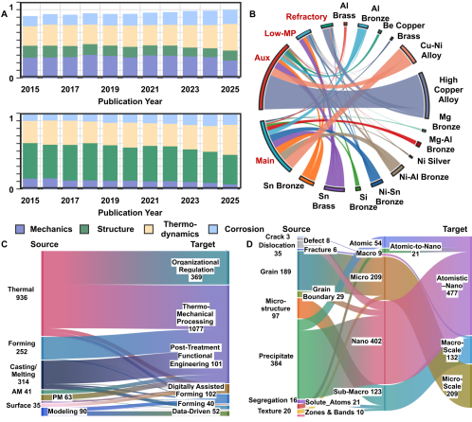
Supplementary Fig. S4. Distribution and knowledge coverage of the final structured CPSP database.(A) Annual normalized distributions of mechanics-, structure-, thermo- dynamics-, and corrosion-related research represented in the database from 2015 to 2025. (B) Relationships between copper-alloy systems and main, auxiliary, low-melting-point, and refractory alloying-element categories. (C) Relationships between source processing descrip- tions and normalized processing-route categories. (D) Relationships between extracted structural descriptors and their atomic-to-macroscopic scale classifications.

The CPSP infrastructure reconstructed in this study comprises 3,245 publications and 9,284 structured CPSP records. Supplementary Fig. S4 further characterizes its knowledge coverage from three complementary dimensions: the distribution and compositional relationships of copper-alloy systems, the coverage of processing routes, and structural information across characteristic length scales. Together, these dimensions describe how composition, processing, and structure are organized within the final CPSP database.
Supplementary Fig. S4A and B show that the reconstructed records span diverse copper-alloy families and research domains rather than a single compositional space. The literature covers mechanics-, structure-, thermodynamics-, and corrosion-related research, while the alloy systems include high-copper alloys, Cu–Ni alloys, brasses, nickel silver, and multiple bronze families, including Al-, Be-, Mg-, Ni–Al-, Ni–Sn-, Si-, and Sn-containing bronzes. Their relationships with main, auxiliary, low-melting-point, and refractory alloying elements further preserve the compositional connections among different alloy families and alloying strategies, demonstrating broad coverage of the Cu-based compositional space.
Supplementary Fig. S4C extends this coverage to processing histories, including thermal processing, forming, casting and melting, additive manufacturing, surface processing, powder metallurgy, and modelling, together with their normalized processing categories. These relationships preserve preparation, deformation, heat-treatment, surface-modification, and post-treatment information, providing the intermediate processing layer required to reconstruct Composition–Processing–Structure–Property/Performance relationships rather than reducing the literature to composition–property pairs.
Supplementary Fig. S4D further organizes structural information across atomic, nanoscale, microscale, sub-macroscale, and macroscale levels. Extracted descriptors include precipitates, grains, microstructure, segregation, texture, dislocations, and cracks, together with more specific features such as solute atoms, zones and bands, grain boundaries, and defect- and fracture-related information. Thus, the reconstructed structure layer preserves information ranging from solute and defect states to nanoscale precipitation, grain-scale microstructures, and larger-scale structural characteristics.
Collectively, these distributions demonstrate that the final database constitutes a structured CPSP knowledge infrastructure rather than a conventional composition–property table. By integrating diverse copper-alloy systems, alloying-element relationships, processing histories, and multiscale structural information, it provides a reusable basis for task-specific dataset generation, CPSP relationship analysis, knowledge-informed feature engineering, machine learning, and subsequent alloy design.

References
- Blei DM, Ng AY, Jordan MI, 2003. Latent dirichlet allocation. J Mach Learn Res. 3, 993–1022.
- Grootendorst MR, 2022. BERTopic: Neural topic modeling with a class-based TF-IDF procedure. ArXiv. abs/2203.05794,
- McInnes L, Healy J, Melville J, 2018. Umap: Uniform manifold approximation and projection for dimension reduction. arXiv preprint arXiv:180203426.
- Agrawal A, Choudhary A, 2016. Perspective: Materials informatics and big data: Realization of the “fourth paradigm” of science in materials science. APL Materials. 4, https://doi.org/10.1063/1.49 46894.
- Butler KT, Davies DW, Cartwright H, Isayev O, Walsh A, 2018. Machine learning for molecular and materials science. Nature. 559, 547-55. https://doi.org/10.1038/s41586-018-0337-2.
- Ward L, Agrawal A, Choudhary A, Wolverton C, 2016. A general-purpose machine learning framework for predicting properties of inorganic materials. npj Computational Materials. 2, 16028. https://doi.org/10.1038/npjcompumats.2016.28.
- Jain A, Ong SP, Hautier G, Chen W, Richards WD, Dacek S, et al., 2013. Commentary: The Materials Project: A materials genome approach to accelerating materials innovation. APL Materials. 1, https://doi.org/10.1063/1.4812323.
- Lookman T, Balachandran PV, Xue D, Yuan R, 2019. Active learning in materials science with emphasis on adaptive sampling using uncertainties for targeted design. npj Computational Materials. 5, 21. https://doi.org/10.1038/s41524-019-0153-8.
- Chen T, Guestrin C, 2016. XGBoost: A Scalable Tree Boosting System. Proceedings of the 22nd ACM SIGKDD International Conference on Knowledge Discovery and Data Mining.
- Ke G, Meng Q, Finley T, Wang T, Chen W, Ma W, et al. LightGBM: a highly efficient gradient boosting decision tree. Proceedings of the 31st International Conference on Neural Information Processing Systems; Long Beach, California, USA: Curran Associates Inc.; 2017. p. 3149–57.
- Prokhorenkova L, Gusev G, Vorobev A, Dorogush AV, Gulin A. CatBoost: unbiased boosting with categorical features. Proceedings of the 32nd International Conference on Neural Information Processing Systems; Montréal, Canada: Curran Associates Inc.; 2018. p. 6639–49.
- Guyon I, Weston J, Barnhill S, Vapnik V, 2002. Gene Selection for Cancer Classification using Support Vector Machines. Machine Learning. 46, 389-422. https://doi.org/10.1023/A:101248730279 7.
- Smola AJ, Schölkopf B, 2004. A tutorial on support vector regression. Statistics and Computing. 14, 199-222. https://doi.org/10.1023/B:STCO.0000035301.49549.88.
- Achiam OJ, Adler S, Agarwal S, Ahmad L, Akkaya I, Aleman FL, et al., editors. GPT-4 Tech- nical Report2023.
- Wu Q, Bansal G, Zhang J, Wu Y, Li B, Zhu E, et al., editors. AutoGen: Enabling Next-Gen LLM Applications via Multi-Agent Conversation2023.
- Choi J, Lee B, 2024. Accelerating materials language processing with large language models. Communications Materials. 5, 13. https://doi.org/10.1038/s43246-024-00449-9.

